Personal log Oscar Brændgaard

22/9 2026

Worked on and finished game idea ”The other one” contemplating different aspects of gameplay and rewriting parts i didnt like or adding new features. Realised that i had to simplify an aspect of the ”liars game”, to make the game more focused. Did this.

23/9 2026

Talked with the group, heard different pitches and decided to proceed with my pitch. Made a group document and figured out how to share a folder on google docs. Edited the pitch a little bit before we decided it was good enough.

25/9 2026

Did group work today with my team over Discord. Discussed how a core mechanic should work, and how it should be expressed. Discussed what a core loop was, we disagreed for a while on what constitutes a loop but in the end settled on something we could agree on. I wrote in the document with them. We discussed how to handle Neheimias not being there without communication.

30/9 2026

We did group work at Uni where we adjusted our game prototype by narrowing down the action squares, exactly what they do and how they worked. We tested these interactions through internal playtesting again, found out some of the interactions were frustrating and adjusted accordingly. We added modifiers to our playcards.

2/10 2026

Worked at first on the modifier cards and wrote down the game rules in a folder, the modifier card rules and the action square rules in 3 seperate folders, while discussing how to formulate it with the group. Made the action squares into symbols instead of text, adjusted their position on the board and drew the design of the action square symbols. We adjusted the rules, action squares and modifier cards and got ready for external playtesting. We all playtested the other groups game together. We wrote down observations while the other group playtested our game.

7/10 2026

We rewrote and discussed the rule book, considering many different formulations and having issues making a precise language. Found out that the language is difficult and important when making rulebooks. Adjusted the board some more, removing unhelpful interactions making the game more balanced. We give it another internal playtest before agreeing to get another group to playtest before submitting our game.

9/10 2026

Some confusion today. We agreed to meet at 9:30 for a playtest, it dragged out a bit and suddenly the group remembers there is team hour. I showed up at this time to playtest but had forgotten it aswell, had to go myself. So, we agreed to talk after the 2 remaining team members playtested the other groups game and so on. We communicated over Discord and got to a point where we agreed to deliver the assignment

23/10 2026

Spending some time today reading the design brief and getting to know Pico-8. Trying to organize with the group on how to approach the project. Frustrated over being sick and feeling the time pressure, getting acquainted with the slides I missed yesterday and planning the weekend, so that I can get a core mechanic and the requisite pico-8 knowledge ready for next team meeting.

26/10 2026

We haven’t talked in the group since last week, i wrote this morning to ask if we should begin the project but so far no answers, so i decided to start developing my own concept for the group work and go on to a paper test when i am ready. The concept that i made today is: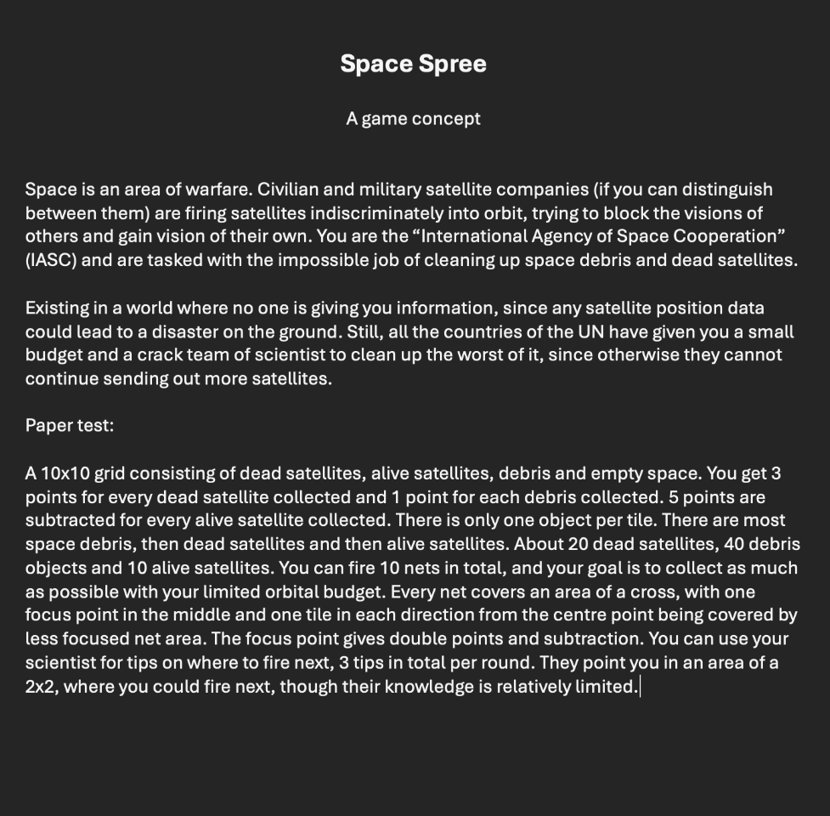

I am making a paper test to see if it is any fun, but wont be testing it today.

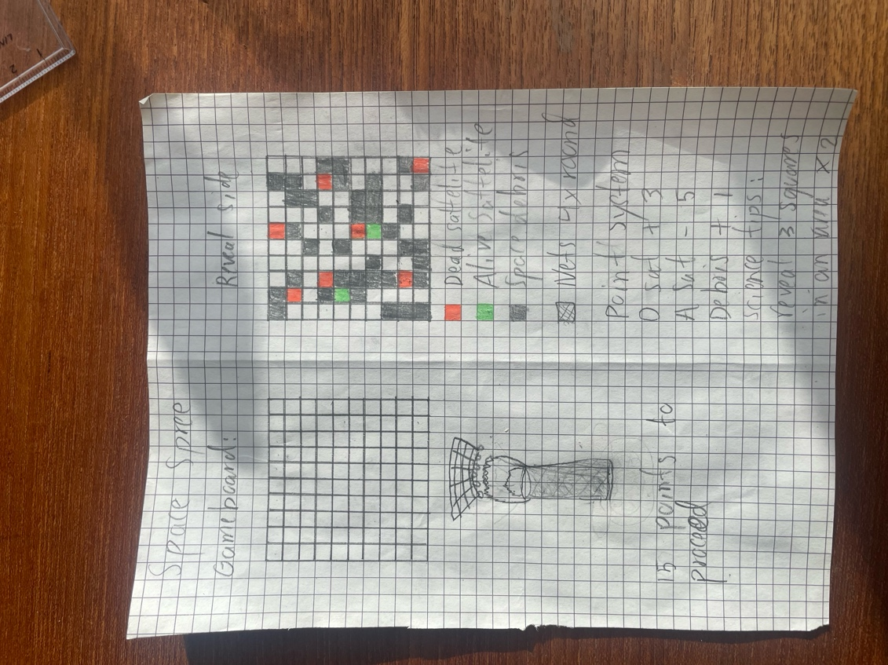

29/10 2026

Got curious about the core mechanic, so tried to work the game through Claude, with the paper test as a basis, to a working prototype. Found balancing issues quickly (many point values need to add up to a feeling of difficulty, but not too much. Gave it very specific instructions and added a new element, an asteroid. Its still very unbalanced and wonky, but there is actual excitement with the core mechanic and the flow of the game is not too impeded.

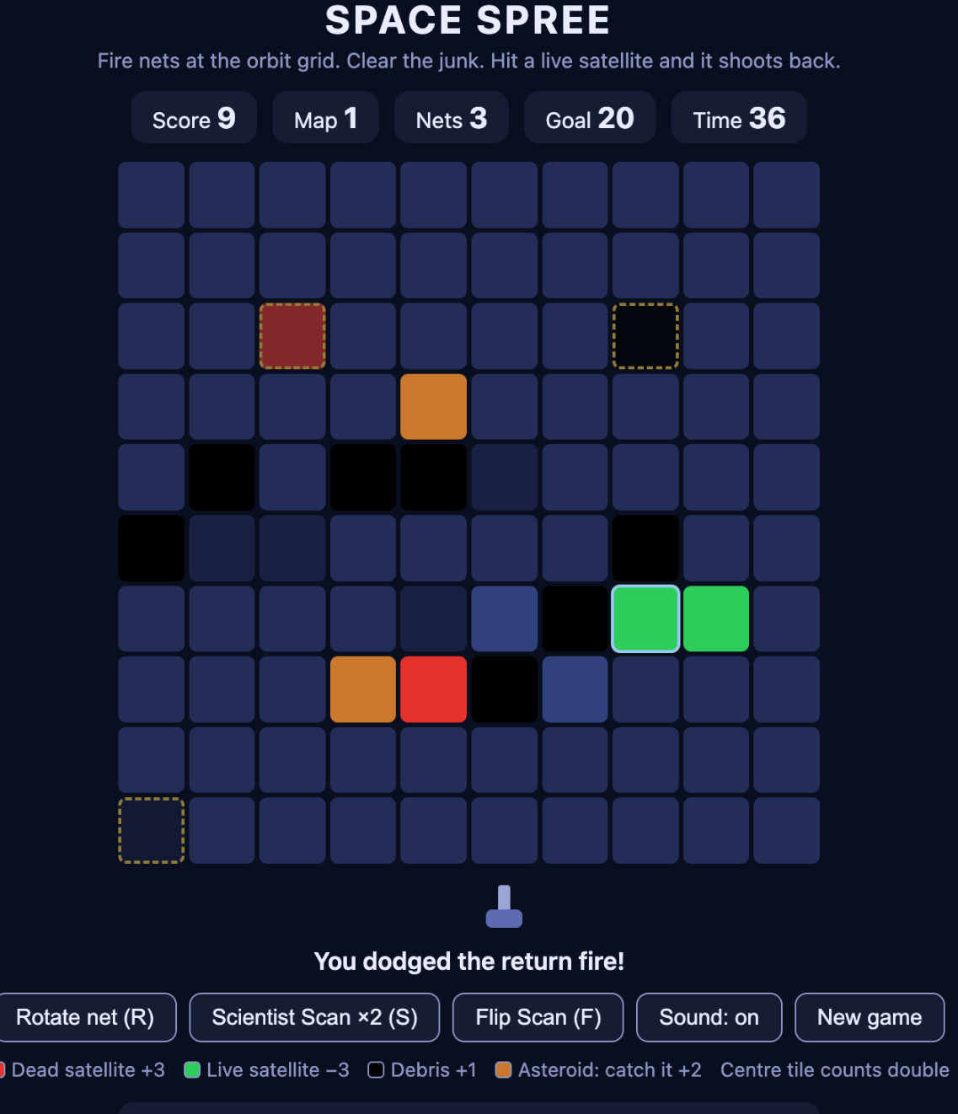

30/10 2026

Met with the group today and we agreed to go with ”Space Spree”. I showed them the Claude demo, which we used to test the core mechanic and agreed that the core mechanic worked and we could continue working on it.

Made group files we could work on, made a diagram and a one sentence catch-all. Worked in Pico-8 and collaborated with Nehemias on creating the timer system and looked into how sprites are created. Made sprites for the game board and collected the Pico-8 data from the others, created a shared game file, polished the syntax and made a repository, where we could edit the code file together. Looked into how the grid system should work and planning how to work on the reveal tile mechanic for Wednesday.

3/11 2026

Worked on the reveal mechanic today in pico-8, ended up reworking the grid function and adding variables such as offset_x and y, so that I can adjust the positioning of the grid, also a tilesize, so that the tilesize can be adjusted in the function as a variable. Made a cursor and made it functional in the code, made a little sprite and assigned it to the stat 32, 33 and 34, so that It could be used. Made the grid smaller and in the center of the screen, much nicer to look at. Learned how I would proceed with the reveal mechanic, made the tiles interactable with the mouse cursor, but not selectable yet.

